**DAILY ONLINE ACTIVITIES SUMMARY**

|  |  |  |  |  |  |  |  |
| --- | --- | --- | --- | --- | --- | --- | --- |
| **Date:** | | **31/05/2020** | | | | | |
| **Name of the Faculty** | | **Shruthi Shetty J** | | | | | |
| **No. of Students Allotted for monitoring** | | | | | **26** | | |
| **Progress** | | | | | **Good** | | |
| **Whether collected report from all the allotted students** | | | | | **22** | | |
| **Online Test Summary** | | | | | | | |
| **Subject** | **Operation Research test** | | | | | | |
| **Semester** | **6** | | | **Duration** | | **1 HOUR** | |
| **No. of students Taken** | | | **106** | **Passing %** | | **96%** | |
| **Certification Course Summary** | | | | | | | |
| **Course** | | 1. Started with certification course on Network Security on Alison.com. 2. Searched technical paper related to “Energy efficient secure algorithms for edge devices in IOT”. 3. Completed consolidated Report on student allotted from 18-5-2020 to 31-5-2020 | | | | | |
| **Certificate Provider** | | **Alison.com** | | | **Duration** | | **3hours** |
| **Coding Challenges** | | | | | | | |
| **Problem Statement:** Shared set of questions given on Bootcamp. Informed students to solve problem in python programming language. | | | | | | | |
| **Status: 22 completed** | | | | | | | |
| **Uploaded the report in Github** | | | | | **Yes** | | |
| **If yes Repository name** | | | | | <https://github.com/ShruthiShettyJ/daily-report> | | |
| **Uploaded the report in slack** | | | | | **Yes** | | |

Online Test Details: (Attach the snapshot and briefly write the report for the same)

Certification Course Details: (Attach the snapshot and briefly write the report for the same)

Coding Challenges Details: (Attach the snapshot and briefly write the report for the same)

**Certification Course Summary:**

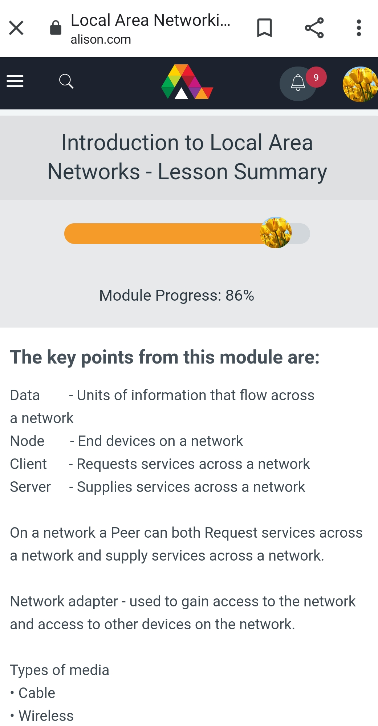**Sample Students Report:**

